RESUME 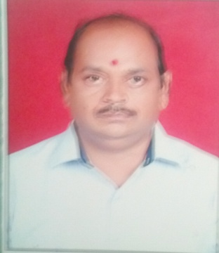
1. Personal Information:

Full Name – MANOJ PURSHOTTAM PATIL

Date of Birth – 29TH NOV. 1970

Designation – INSTRUCTOR CARPENTER

Email Address – manojpatil291170@gmail.com

2. Academic Profile:

Sr. No. | Education | University | Percentage | Passing Year | Specialization | Special Honour
1 | I.T.I | Delhi board | 73.00 | 1991 | carpenter | Dist.
2 | A.T.I | Saion Mumbai | 76.00 | 1995 | carpenter | Dist.
3 | B.A. | Pune university | 62.00 | 1994 | Marathi

3. Experience Details: 15 Years.

Sr. No. | Organization / Institute | Designation | Working Period | Discipline
1 | Government College of Engineering, Jalgaon | Instructor Carpenter | 02/06/2015 to till date | Workshop
2 | Government Polytechnic Nashik | Instructor Carpenter | 06/06/2011 to 01/06/2015 | Workshop
3 | Government College of Engineering, Jalgaon | Instructor Carpenter | 02/06/2006 to 08/06/2004 | Workshop
4 | Government Polytechnic Dhule | Instructor Carpenter | 16/08/2004 to 16/8/2006 | Workshop
5 | Government Polytechnic Jalgoan | Instructor Carpenter | 24/01/2000 to 16/8/2004 | Workshop

- STTP

Sr. no. | Title | Details of organizing body | Venue | Duration
1 | Recent trends in W/S Techo. | TEQIP | Government College of Engineering, Jalgaon | 09/01/2017 to 13/01/2017

